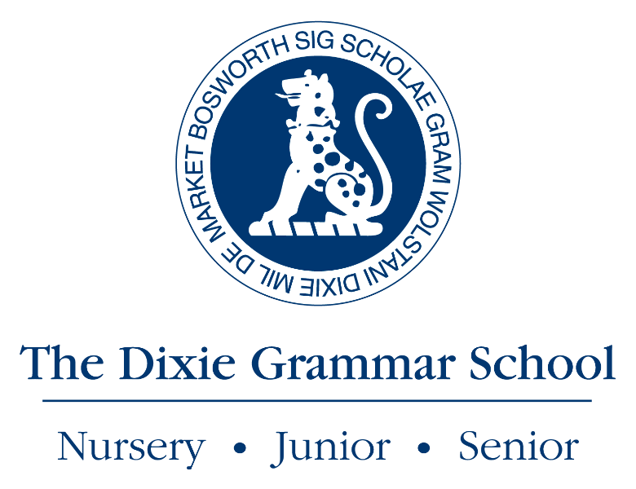

Person Specification – Business Manager of the Dixie Grammar School

The Business Manager of the Dixie Grammar School will be an experienced, highly qualified manager and leader. A proven track record in a broad leadership role including responsibility for finance, IT and business administration is essential, ideally with some experience of estates management. The ability to motivate and influence in a collaborative, team based environment and to think strategically is also essential. The Business Manager will be a strong leader and positive team player who is able to work effectively with a wide range of people.

Previous experience in a school is helpful, but not a requirement. However, a strong commitment to education and to independent education in particular, is viewed as essential. Candidates should appreciate the particular demands of working in the sector and understand that the ultimate aim of the School is an educational one.

A - Application, I – Interview, R – Reference, D – Document check

 | Essential | Desirable | Identified
Education and Qualifications

Honours Degree |  | ✓ | ARD
Chartered Accountant |  | ✓ | ARD
Chartered Secretary |  | ✓ | ARD
IOSH Managing Safely qualified |  | ✓ | ARD
Experience

A proven track record of achieving excellent results | ✓ |  | AIR
Evidence of successful senior management | ✓ |  | AIR
Evidence of successful leadership in a complex organisation | ✓ |  | AIR
Involvement in financial planning and budgeting | ✓ |  | AIR
Experience of being involved in Estates management |  | ✓ | AR
Experience of being involved with management of IT hardware/software | ✓
Experience of being involved in catering and facility management |  | ✓ | AR
Experience of co-ordinating and managing building projects |  | ✓ | AR
Knowledge and Skills

Able to chair and be secretary to meetings | ✓ |  | AIR
Working knowledge of payroll matters |  | ✓ | AIR
Working knowledge of contract law, leasing, employment legislation and charity law, purchasing, insurance matters. |  | ✓ | AIR
Knowledge of the Schools’ education sector |  | ✓ | AI
Excellent communication skills | ✓ |  | AIR
Competent IT skills, knowledge of accounting and administration systems | ✓ |  | AR
Able to prioritise short, medium and long term plans to ensure objectives are achieved | ✓ |  | AR
First-class planning, analysis and organisational skills | ✓ |  | AR
Personal competencies and qualities
A strategic thinker, intellectually strong, able to initiate and develop fully key concepts and ideas | ✓ |  | AIR
Excellent inter-personal skills | ✓ |  | IR
Ability to manage time demands and ensure deadlines are met | ✓ |  | AR
Awareness of, and empathy with, the ethos of the Dixie | ✓ |  | I
A willingness to contribute to the School’s ethos | ✓ |  | I
The ability to lead and motivate several specialist teams | ✓ |  | AIR
The ability to manage and effectively influence a diverse range of stakeholders | ✓ |  | IR
Can show enthusiasm, tenacity and resilience with the ability to work under pressure, while maintaining a sense of humour | ✓ |  | IR

